[Microsoft Teams for Students]
Purpose of the document: Assist Students with Microsoft Teams.

Prepared by:
Denis Perron – Senior IT Technician – Telfer School of Management

In Collaboration with:
Jean-Philippe Seguin – Senior IT Technician – Telfer School of Management
Alexandre Belanger – Senior IT Technician – Telfer School of Management
Philip Beaulieu – Manager, IT Support Services – Telfer School of Management
Jeffrey Lanthier – Senior Manager, IT Support Services – Telfer School of Management
Abdul H. Kane – Instructional Designer – Telfer School of Management

Translation & revision:
Cynthia Coutu Ross – Specialized Library Technician – uOttawa Library
Pierre Renaud – Web Content Management Specialist – uOttawa Library

Special thanks:
Cecilia Tellis – Head, Design and Outreach – uOttawa Library
Joey Kilbride – Web Developer – Telfer School of Management

Introduction

What is Microsoft Teams:
- Microsoft Teams (MS Teams) is a digital hub that brings conversations, content, assignments, and apps together in one place. It can be used by professors and teaching assistants to give their lecture via an online meeting.

Within MS Teams, students can quickly converse with professors and other students, share files, create a OneNote class notebook, view their assignments and grade amongst other possibilities.

How to Get Started with Microsoft Teams

Downloading Microsoft Teams
- The desktop application offers the most compatibility. (See Hardware Requirements)
Telfer IT only supports and enforces the use of the desktop application.

- All active students have access to MS Teams and should log in using their uoAccess credentials.

Access your Team Class
- You should receive a welcome e-mail, when added and invited, to a class team in your uOttawa e-mail.
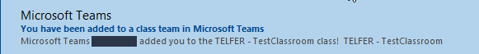

- Using the desktop application, log into MS Teams using your uoAccess ID.
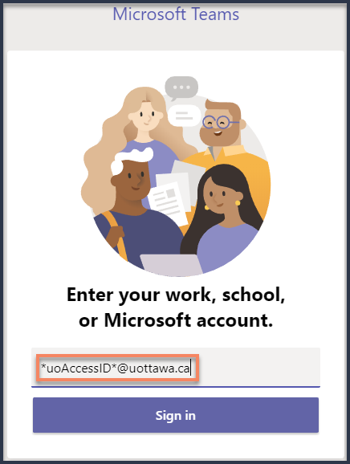

- A redirection to uOttawa website will follow, asking you to enter your password
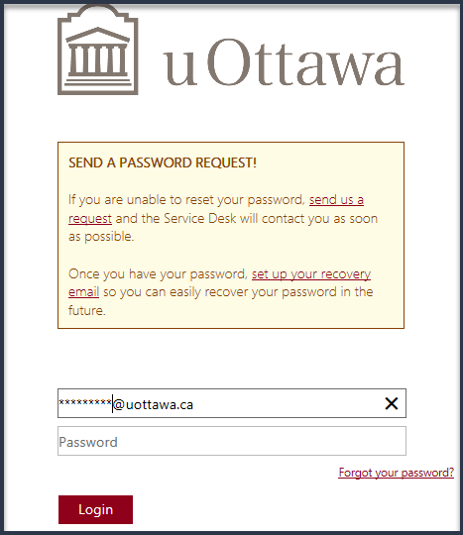

- Once logged in, on the left navigation bar, select Teams.
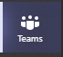

- All enrolled classes should appear here.
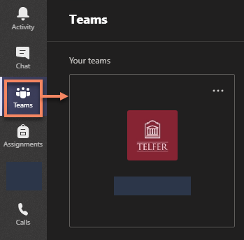

- If you do not see your class, please contact your professor to be added manually.

Meetings

Joining Teams Meeting:
Always validate the e-mail address of the sender before clicking on any links
Your classroom meeting invite will come from your professor or “Class_Name@uottawa.onmicrosoft.com”.
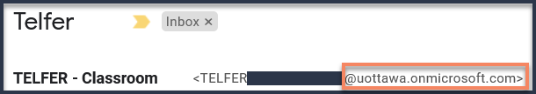
All Join Microsoft Teams Meeting link address begins with “https://teams.microsoft.com/…”.
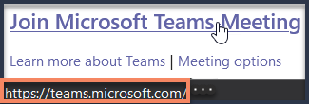

- In a meeting invite, select Join Microsoft Teams Meeting.
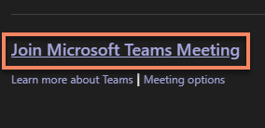

- Select one of the supported methods to open the application
  - Launch it now to open the application and proceed with a secure sign in.
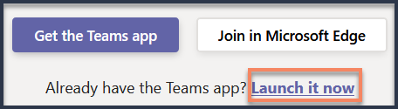

  - (Alternative pop-up window) Under Launch application select Microsoft Teams and Open link.
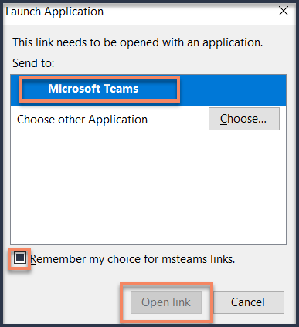
Note: You can check the box Remember my choice or msteams links to skip this window next time.

- If you have never signed in the application before, Log in with your uoAccess credentials.
See Access your Team Class above for a step by step guide.

- Choose the audio and video settings you want. (Some of these settings may be set by the Professor by default.)
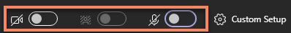

- Select Join Now to enter the meeting.
- Watch the “Join a Team meeting” video (01:31 min)

What to do During a Meeting
During a meeting, moving your cursor on the screen will bring up the meeting controls toolbar.
Some of the most used options will be explained in detail below.

Meeting control toolbar: | More Actions:
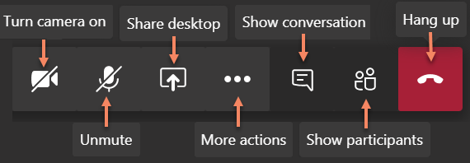 | 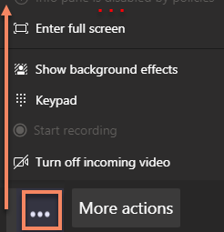

- Manage audio settings
  - Click on More actions and select Show Device Settings

  - Check and change your Device Settings by desired Audio Device, speaker, microphone and camera.
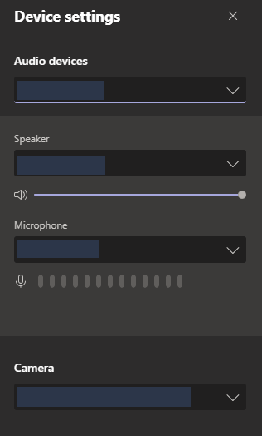
Note: If your device is not found, best practice is to reconnect your device and see if it appears.

- Share your screen
It is recommended to ask your professor before sharing your screen.
If the option is not available, your professor may have turned this function off.
  - To share your screen in a meeting, select Share in your meeting controls.

  - Then, choose to present your entire desktop or a specific window or application
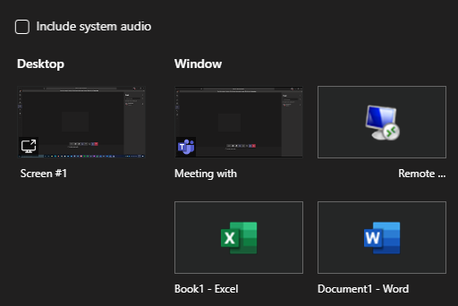
Note: If you are using MS Teams on the web, certain functions will not work. Please download the application for full functionalities.

  - (Optional) Share system audio
    - To share your system audio, select Share in your meeting controls and then Include system audio.
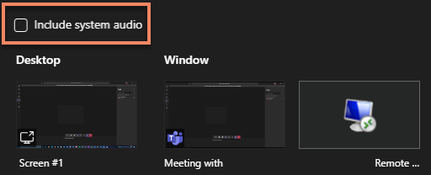
Note: All system audio, including notifications, will be included in the meeting.

  - When you are done sharing, go to your meeting controls and select Stop sharing button.
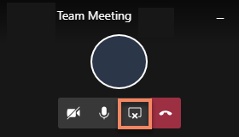
    - Watch the “Show your Screen during a meeting” video (00:47 min)

- Chat with Professor or other students
  - Click on Show Conversation to bring up the chat interface.

  - The Chat pullout menu will appear on the right-hand side of the screen.
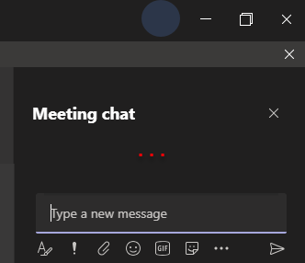
Note: See Best Practices and Troubleshooting section if the chat is not working for you.

- Multitasking in a meeting
    - Watch the “Move around during a Teams meeting” video (00:51 min)

- Adjust your view in a Teams meeting

- Change (or Blur) your background
If you prefer your camera on during a lecture, you have a few background effects that you can choose from.
  - Click on More actions and select Show background effects.

  - Select one of the predefined background settings. This includes None/revert to revert to normal & Blur as the first options
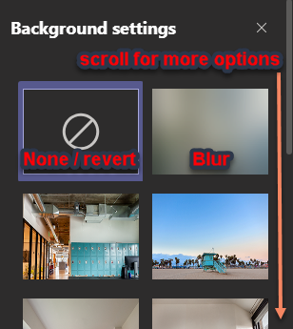

- Whiteboard
- Only a presenter can open the whiteboard app. They can choose to set it to Read Only (option only accessible via the app).
Note: It’s important to be respectful and not write on the whiteboard unless you ask the Professor permission before doing so.

- Keyboard shortcuts for Teams meetings

Recordings

Recording a meeting

Recording a meeting is only available to the meeting organizer. Students (and other members) will have the options greyed out.
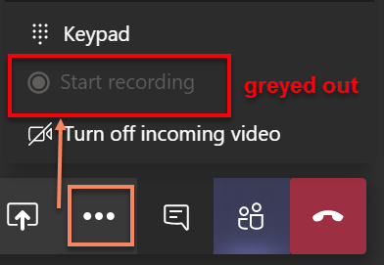
Professors can promote a user (such as a Teaching Assistant) to a presenter to have them record the meeting on their behalf.

*** IMPORTANT NOTE: Some of these functions will not work unless your professor or teaching assistant has given you access. Please contact your Professor or Teaching Assistant to request access. ***

If your professor choses to record the class meeting:
- A message will be displayed at the top of MS Teams to advise you.
Note: Link to Privacy policy concerning the recording of meetings.

- Once the recording has stopped, a message will be displayed it is being saved at the top of the window and within the chat..
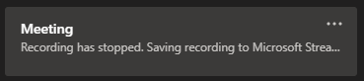
Note: This could take some time depending on the size of the file.

- Once completed, the recording will appear in the Chat that the meeting took place (normally General).
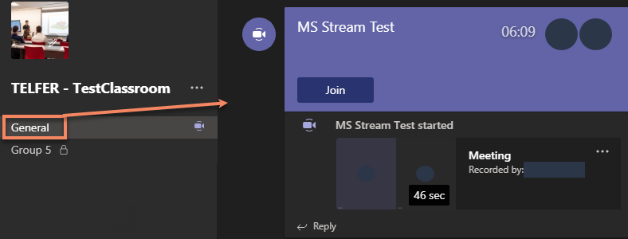

Play and share a meeting recording
When a recording finishes, students will not have access to the recording until the author gives access.
Please contact your Professor or Teaching Assistant to request access.

- From the recording available in chat, click on the More options button next to the recording to access the options available.
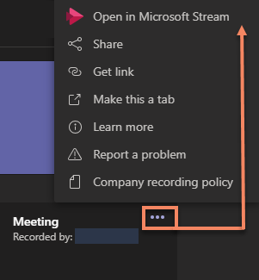

- Select Open in Microsoft Stream to view the recording.
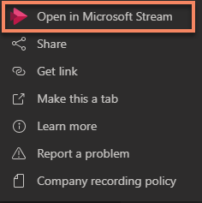
Note: Login with your uoAccess credentials.

- The Share button is only available to the author, or an authorized user, within Microsoft Stream
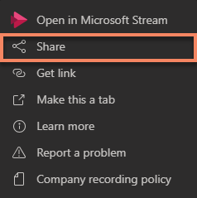

- The Get Link option allows you to quickly Copy the link.
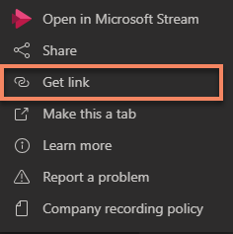

  - Click the Copy button to automatically grab the entire Stream link.
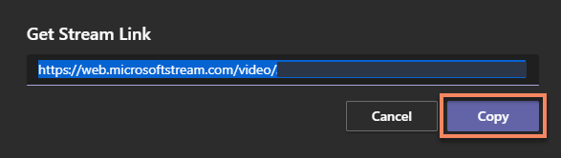

  - Users will still need to sign in a Microsoft Stream account to access the recording
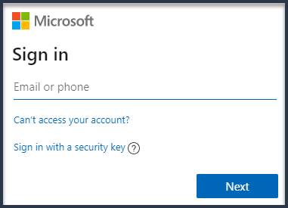
Note: Only uoAccess credentials can view the recording directly from Microsoft Stream

Download a recording
A video recorded can only be downloaded from the author, or an authorized user, within Microsoft Stream.
Please contact your Professor or Teaching Assistant to request access.

- Log into Microsoft Stream and view your recording or select a recording’ More options > Open in Microsoft Stream.
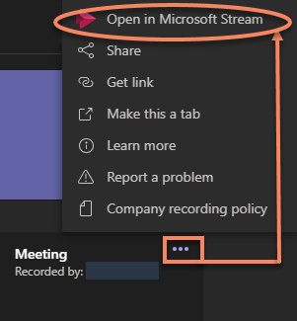
Note: Login with your uoAccess credentials.

- Click the More options button and select Download video.
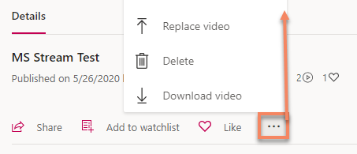
Note: Once you click download, the file will automatically save as an mp4 with your selected browser.

Delete a Recorded meeting
A video recorded can only be deleted from the author, or an authorized user, within Microsoft Stream.

Best Practices and Troubleshooting

Audio and Microphone
- In the meeting controls toolbar, check to see if you are muted.
Muted
Unmuted

- If you encounter difficulties with your audio or microphone, reconnect the device on your computer and see if it appears under Show Device Settings.
See Manage audio settings for more details

Videoconferencing
- Position the camera as close to eye level as possible. For best picture quality, do not have a bright light source or window as your background.

- If possible, use a wired internet connection. If you use a wireless connection, ensure you are close to your router to maximize signal strength.

- If you experience freezing video or audio dropouts during a call, there are a few settings that you can change that could improve your conference performance:
  - Turning your camera off:
- Bring up the meeting controls toolbar by moving your mouse over the screen.

- Click on the camera icon to turn it off.
Camera On

Camera Off

  - Turn off all incoming video:
- Bring up the meeting controls toolbar, click on More actions
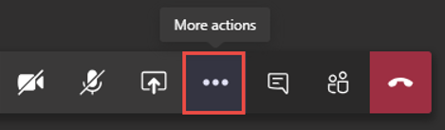

- Select Turn off incoming video.
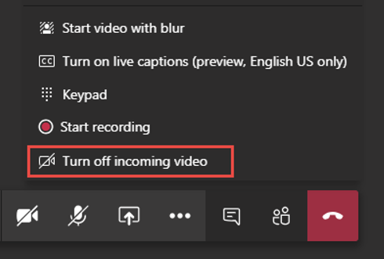

Chat & Guest Access
- The Show conversation allows students and professors to chat during the meeting. It is also a way for professors to leave quick notes, files or links during the class.
- If the Show Conversation function is not working:
  - Your professor may have turned off Chat.
    - If the Professor has disabled chat, you’ll be able to bring up the Show Conversation interface but will be unable to chat.
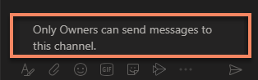

    - Contact your professor to discuss about the possibility of reactivating the Meeting chat functions.
You can send a private message to your professor by using the Search or type a command at the top of MS Teams.
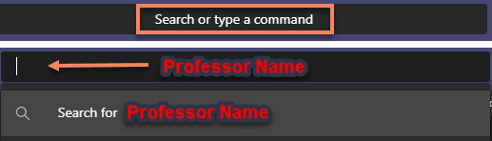
Note: While Chat is useful in a bind, your professor may request not to communicate via Chat.
It is encouraged you use their preferred method of communication. (Ex: e-mail / Brightspace / Other)

  - You may have entered the Meeting as a Guest.
    - If you have copied the link from an e-mail and are being asked to enter a display name, this is called joining as a guest.
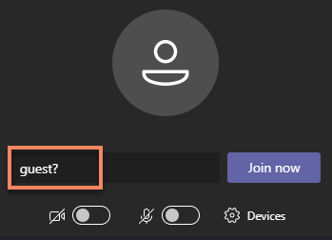

    - Guests have limited functionalities. You will not be able to bring up the Show Conversations nor chat with other students or the professor.
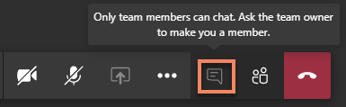
Note: To avoid entering a meeting as a guest, see How to Get Started with Microsoft Teams.

Removal from a Teams classroom
In order to be removed from a Teams Classroom, communicate with one of the owners in order to be removed.

- On the left navigation bar, select Teams.

- Go to the Class team you want to be removed from and choose More options > Manage team
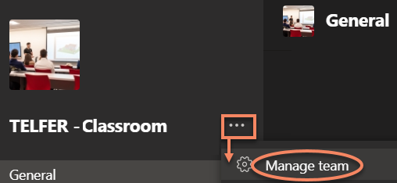

- Under Members, locate the owners. Owners will generally be your professor or your possibly Teaching Assistant.
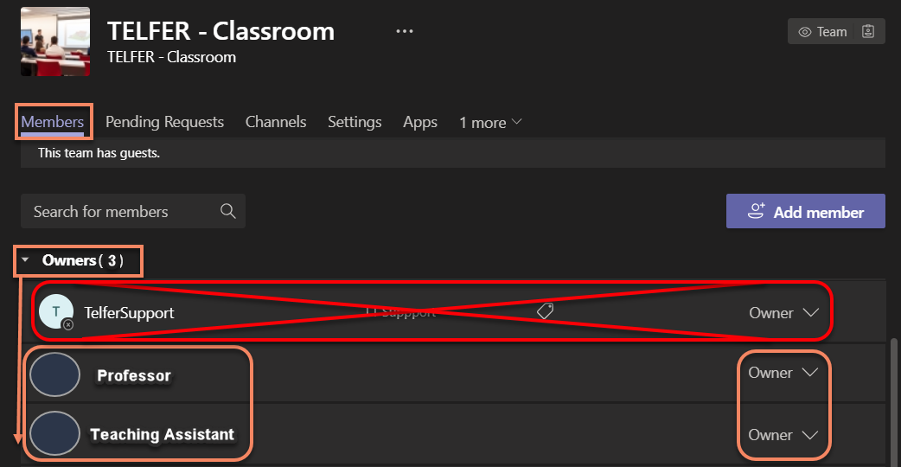
Note: Never contact owner TelferSupport in order to be removed. This account is not monitored.

Important notes

- Students’ accounts are considered members in MS Teams if they log in using their uoAccess credentials.
A member account can be set as an owner. This is useful for inviting a TA to present, host and assist in a Team Class environment. They will not be able to create a Calendar event with their student ID. More details available on Roles of Owners and Members.

- Due to current Web client browser limitations, and the complexity of troubleshooting various browsers and versions, Telfer IT recommends and will only offer supports for the desktop clients. If students or users wish to use the Web Client, more information on the web limitations is available on the Microsoft Teams website.

- While there are many other web conferencing software available on the internet, the University of Ottawa (uOttawa) currently only offers supports with Adobe Connect and Microsoft Teams.

- Team meetings are currently limited to 250 participants in a single meeting session.

Other Useful Links:
  - uOttawa Information Technology - Student Zone
  - Microsoft Teams for Education
  - Microsoft Teams Video Training
  - Microsoft Quick Start Guide
  - Microsoft Interactive Teams Demo
  - Manage your uoAccess account and password

Support inquiries and Password resets
All student inquiries for assistance with MS Teams, including uoAccess Password resets, should be directed to the University of Ottawa’s Helpline:
Note: Only your professor can add you to a Team Classroom. Contact your professor if you can log into MS Teams but are unable to see your class.

  - Phone: 613-562-5800 x6555

  - Online request: https://it.uottawa.ca/request

